Software Engineering – Sprint 3

Contents

User Stories 1

Wireframe 1

Git repositories 2

Kanban Board 3

Meeting Records 3

A screenshot of your github repo + link 4

A screenshot of your taskboard + link 4

Group: Group AB

Members: Anthony White (WHI23592849), Bradley Torres(TOR23593293)

## User Stories

As a **[user]**, I want **[to browse and search for game tips]** so that **[I can improve my gameplay].** As a **[user]**, I want **[to the newest tips to appear on my feed]** so that **[I stay updated on the latest** strategies].

As a **[user],** I want **[to submit game tips and tricks]** so that **[I can share my knowledge with others].** As a **[user],** I want **[delete my posts]** so that **[I can keep my posts accurate and not leave misinformation].**

## Wireframe

Pages

Tabs

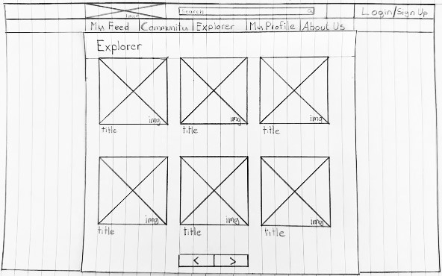

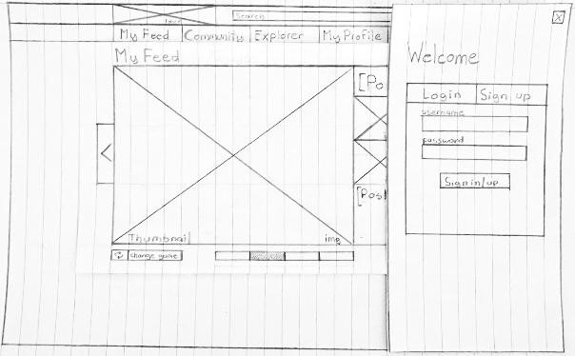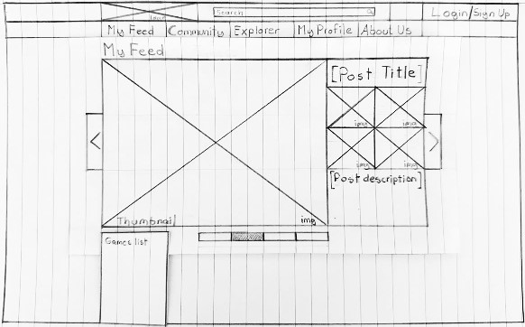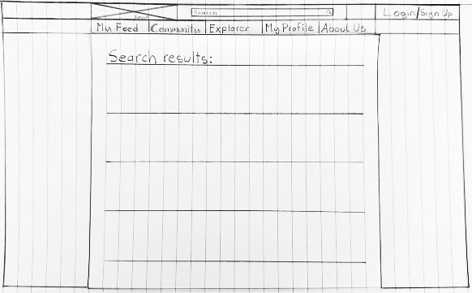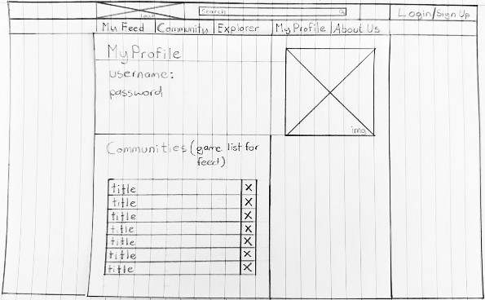

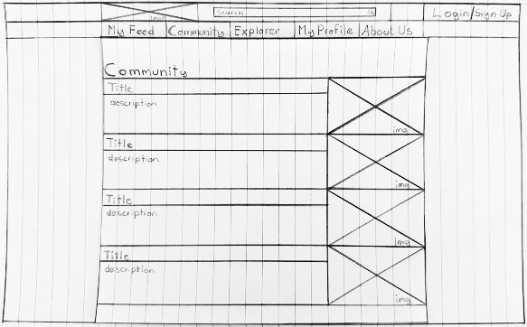

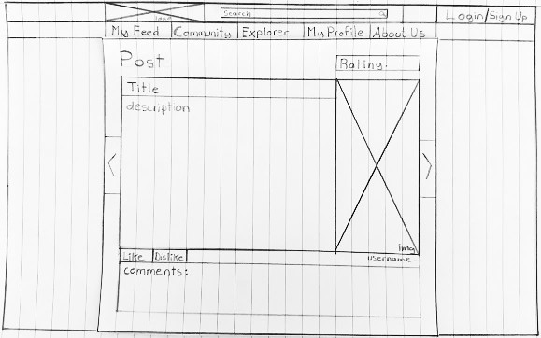

Current Tips Listing

## Git repositories

# Kanban Board

## Meeting Records

Meeting 1

|  |  |
| --- | --- |
| Date | 09/03/2025 |
| Meeting goals |  |
| Attendees | Bradley Torres, Anthony White |
| Roundup updates |  |
| Discussion |  |
| Actions |  |

Meeting 2

|  |  |
| --- | --- |
| Date | 11/03/2025 |
| Meeting goals |  |
| Attendees | Bradley Torres, Anthony White |
| Roundup Updates |  |
| Discussion |  |
| Actions |  |

Meeting 3

|  |  |
| --- | --- |
| Date | 13/03/2025 |
| Meeting goals |  |
| Attendees | Bradley Torres, Anthony White |
| Roundup Updates |  |
| Discussion |  |
| Actions |  |

## A screenshot of your github repo + link

Githublink: https://github.com/xXKARCXx/Sprint_2_SoftwareEng

## A screenshot of your taskboard + link

**Submission requirements for this Sprint:**

Updated task board of user stories showing progress in the technical deliverables.

Github repository showing work from all members of the team

Implementation progress towards final version of application:

- Database design

- Database implementation with pre-filled data

- HTML pages available generated from PUG, showing static content

- At least some dynamic content being pulled from your database to your templates via Pug -

concentrate on views of your data and don’t worry about adding/updating for now.